BBI JU BIORESCUE PROJECT FEATURED IN EURONEWS

*17 December 2019*

**The work of the BBI JU-funded project BIOrescue is explained in the video report that Euronews is broadcasting this week. The project is giving added-value to the mushroom compost that was usually underutilised.**

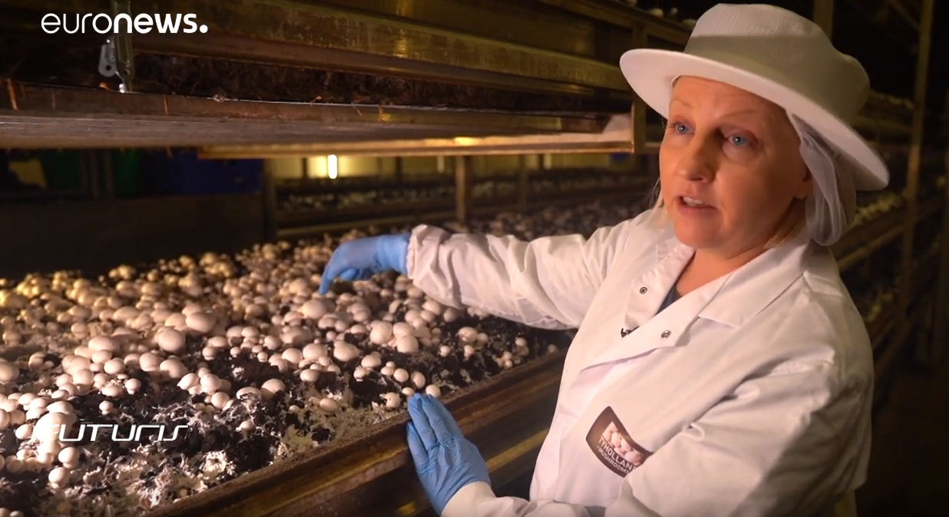Every year the European Union produces more than 1 million tonnes of mushrooms. But there is a downside to this production: every tonne of mushrooms needs three tonnes of compost that is underutilised or thrown away after the harvest. The BBI JU [BIOrescue](https://www.bbi-europe.eu/projects/biorescue) project is focussing on solving this challenge that affects the logistics and the economic performance of mushroom growers.

Mushroom compost is a valuable biomass that can be transformed into many bio-based products. The aim of the BIOrescue project is ‘to use the compost and create much higher value applications that are incredibly useful for society’, in the words of the chief executive of Monaghan Biosciences, MBio.

The BBI JU-funded project has already successfully demonstrated the production of bio-based pesticides. Besides, Spain’s National Renewable Energy Centre, CENER, is leading the research to develop bio-based fertilisers and [bio-based nano-carriers for drugs](https://www.bbi-europe.eu/bio-based-nanocarriers-cure-plant-diseases-first-time). The biopesticides can ‘attack specific species of diseases, whereas with traditional insecticides you eliminate a large part of the insects that are in the field’, CENER biologist Irantzu Alegría says.